## Changing the Lane Markers

1. Select the **Lane Marker** tool in the Markings tab and draw a lane marking for the turning lane.
2. Now double click on the north-south road, select the Lanes tab and change the lane marker to double in the Markings section.

* 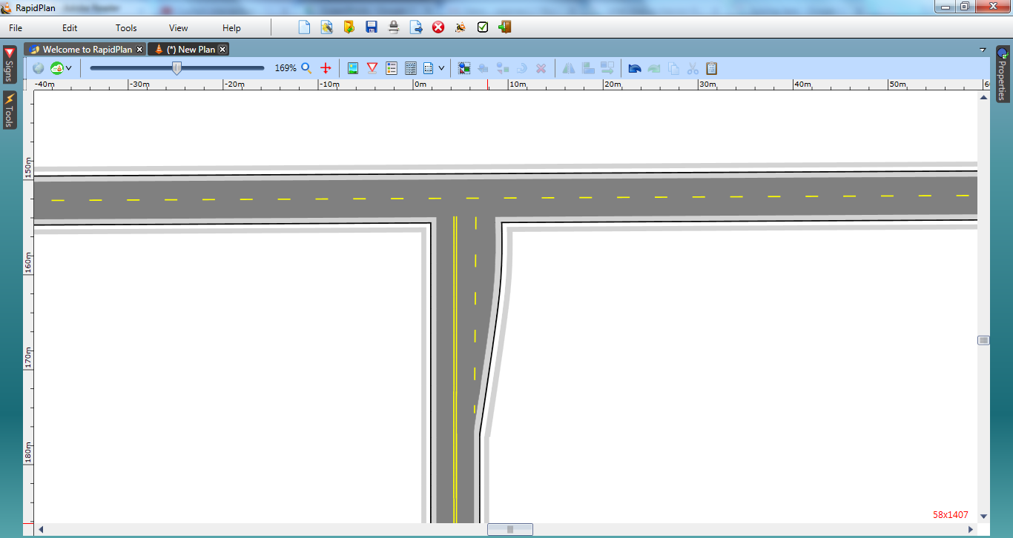
* intersection_Steps_5_and_6